

CSC 431 – Spring 2026

Automated Disaster Settlement (A.D.S)

System Architecture Specification (SAS)

TEAM 6

Danial Haroon | Co-Founder
Alan Fuentes | Co-Founder
Sai Harsha Venugopal | Co-Founder

Version History
Version | Date | Author(s) | Change Comments
1 | 04/02/2026 | Danial Haroon, Sai Harsha Venugopal, and Alan Fuentes | Worked on and finished the System Analysis section of the Doc minus the framework
2 | 04/07/2026 | Danial Haroon, Sai Harsha Venugopal, and Alan Fuentes | Made and added all diagrams
3 | 05/01/2026 | Danial Haroon | Edited and changed all diagrams from drawings to computer drawn diagrams
4 | 05/02/2026 | Danial Haroon | Added framework section and made few edits in wording

Table of Contents

1. System Analysis 6
1.1 System Overview 6
1.2 System Diagram 6
1.3 Actor Identification 7
1.4 Design Rationale 7
1.4.1 Architectural Style 7
1.4.2 Design Pattern(s) 8
1.4.3 Framework 9
2. Functional Design 10
2.1 Disaster Evidence Collection 10
2.2 Event Standardization 11
2.3 Trigger Condition Evaluation 12
2.4 Confidence Score Generation 13
2.5 Evidence Report Generation 14
2.6 Search Verified Events 15
2.7 Map and Timeline View 16
3. Structural Design 17

System Analysis

System Overview

Automated Disaster Settlement (A.D.S.) is a software system designed to verify whether a real-world disaster event occurred within a specific location and time window using trusted public evidence sources. The system supports faster and more consistent disaster-related decision-making by collecting information from multiple external sources, standardizing that information into a unified event record, evaluating whether a defined policy trigger condition has been met, and producing a clear verification result. In addition to the final yes/no decision, the system also generates a confidence score, and an evidence report that explains the basis of the result using traceable source references. This directly supports the project’s goal of reducing delays, inconsistency, and lack of transparency in disaster verification workflows.

System Diagram
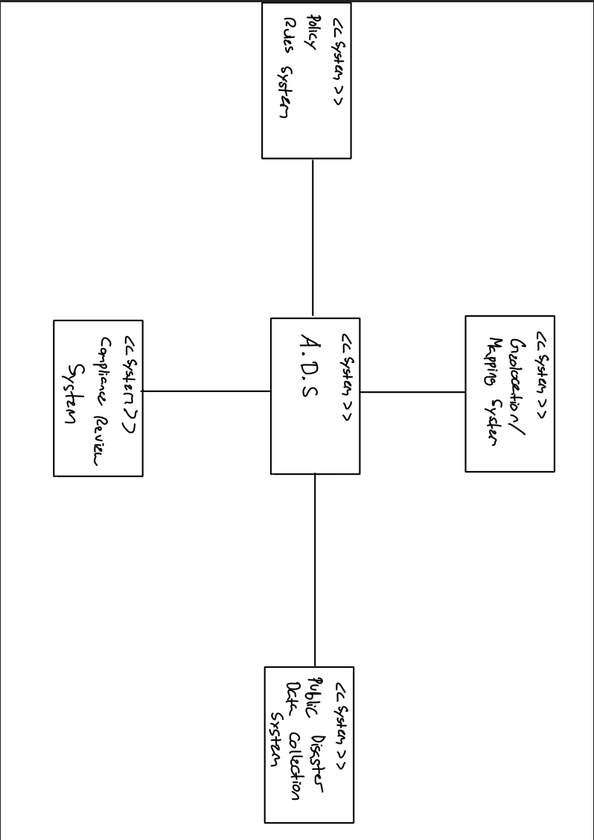

Actor Identification
Risk Manager, Compliance Team

Design Rationale

Architectural Style
We will design using layered architecture separated into four layers: User Interface Layer, Configuration/Control Layer, Application Services Layer, and Utility Services Layer. We decided to use this architecture because ADS is tasked with performing many related but separable functions. These tasks include receiving user input, controlling system coordination, processing evidence, evaluating decisions, report generation, visualization and storing information to persistent storage. Performing these actions across layers allows us to cleanly separate responsibility and should allow for easier maintenance.

User Interface Layer: This layer will be responsible for all interactions with the system's primary user, the Risk Manager. In our case, that will be the ADS User Interface. The user interface will accept inputs such as disaster type, location, time window, and trigger rule parameters. The user interface will also be responsible for displaying outputs such as verification decisions, confidence scores, evidence reports, search results, and the map and timeline view.

Configuration/Control Layer: This layer accepts requests from the user interface, validates user input, and controls system behavior. This layer is responsible for coordinating the overall behavior of the lower-level services by directing requests to the appropriate services. For ADS, this would include the Evidence Collection Controller, Trigger Evaluation Controller, Report Generation Controller, Search Controller, and Map Timeline Controller. These controller classes would allow the configuration/control layer to be the single point of coordination between the user interface and the application services/repositories below.

Application Services Layer: This layer will contain the actual business logic of the application. For ADS, this would include the Standardization Engine, Confidence Scoring Engine, and any other logic used by the controllers to allow users to collect disaster evidence, standardize events, have trigger conditions evaluated, generate confidence scores, create reports, search historical data, and visualize information on the map and timeline.

Utility Services Layer: This layer supports the remainder of the application by providing persistent storage and access to any outside systems or services. For ADS, this would include the Raw Evidence Repository, Event Record Repository, Decision Repository, and Report Repository. This layer would also contain any interfaces needed to communicate with external systems such as the Public Disaster Data APIs, Policy Rule System, and Mapping Service. This layer would also include any infrastructure related services such as logging, monitoring, etc.

Design Pattern(s)
The first pattern that we have implemented in ADS is Model–View–Controller, commonly referred to as MVC. The view in MVC is the ADS User Interface. The UI interacts with the user and displays results. The Controllers are the components that receive input and act on data: Evidence Collection Controller, Trigger Evaluation Controller, Report Generation Controller, Search Controller, and Map Timeline Controller. The last piece is the model, which are domain objects: EvidenceItem, EventRecord, TriggerRule, VerificationDecision, ConfidenceScore, EvidenceReport.

We used this pattern because ADS is meant to complete many actions at the request of the user (submit disaster data to the system, evaluate triggers against user defined criteria, view created reports/visualizations). Separating the UI from the logic that processes data will allow us to easily maintain and scale the design of the system.

The second pattern used in ADS is the Repository Pattern for storing/retrieving data. There are several mentions of a repository for storage in our system design: Raw Evidence Repository, Event Record Repository, Decision Repository, and Report Repository. By implementing the repository design pattern, our controllers and logic will never need to know how data is stored.

Framework
FastAPI: Web framework used as an interface for users to submit requests and linking the front end to microservices that power our system. This was chosen due to its ability to natively handle asynchronous calls allowing for easy retrieval of information from third-party disaster evidence.

Pandas: Used throughout the system to standardize data. We use this to clean and normalize data we receive from multiple sources to create one record per event.

PostgreSQL: Relational database used to persistently store any raw evidence, event record, verification decisions, and reports.

Functional Design

Disaster Evidence Collection
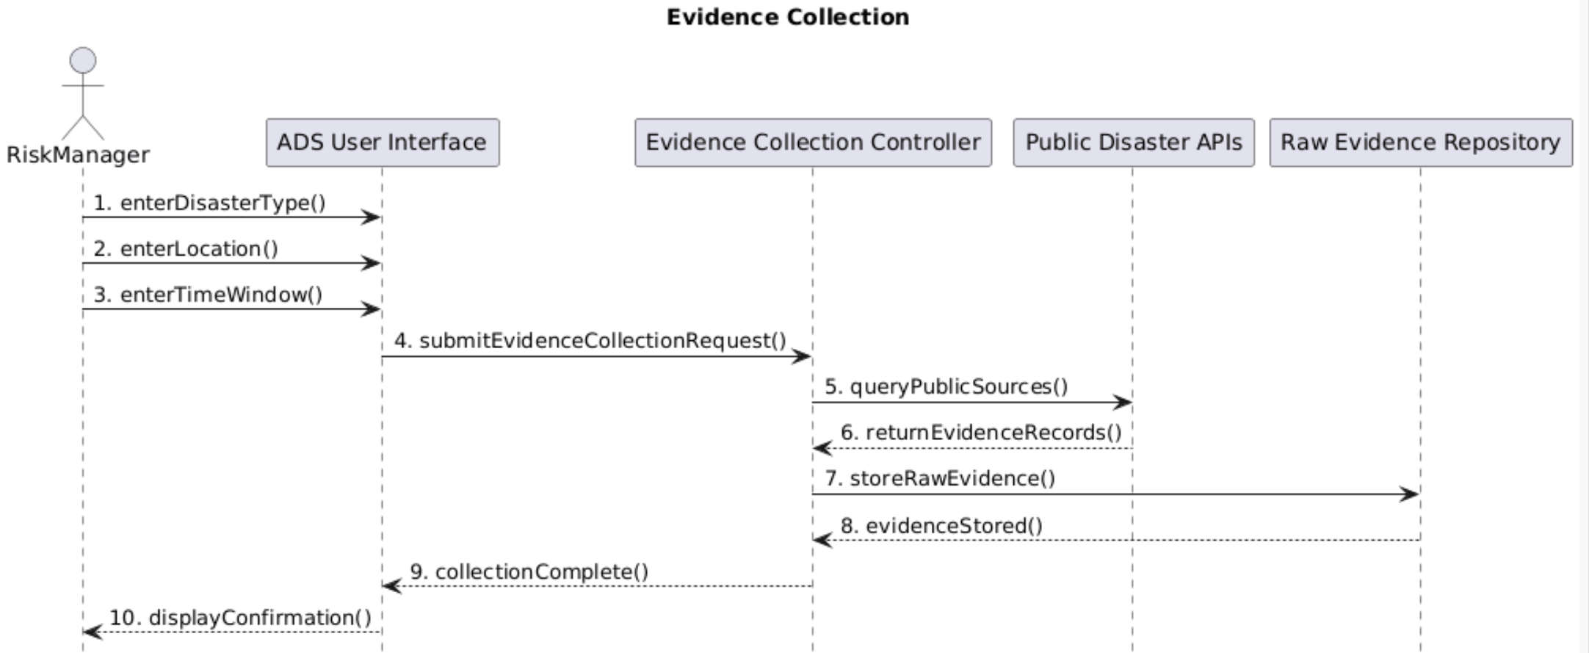

2.2 Event Standardization

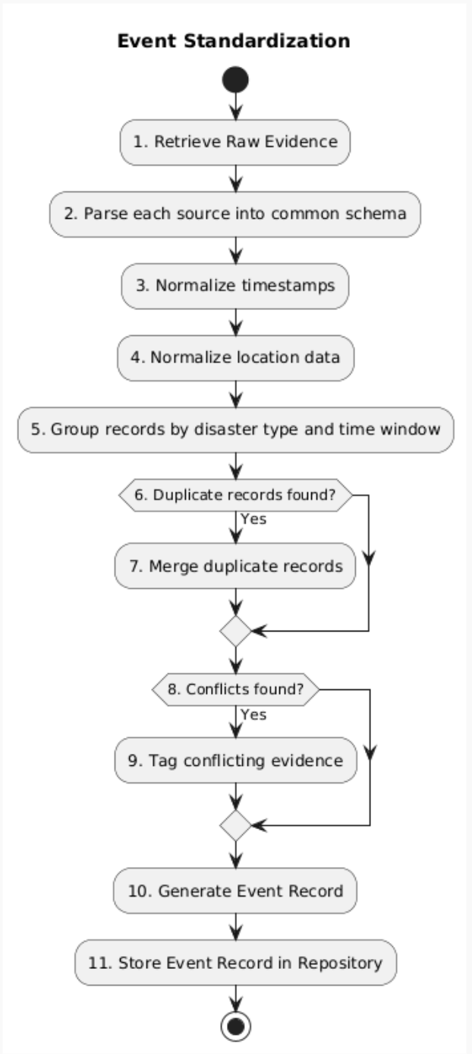

2.3 Trigger Condition Evaluation

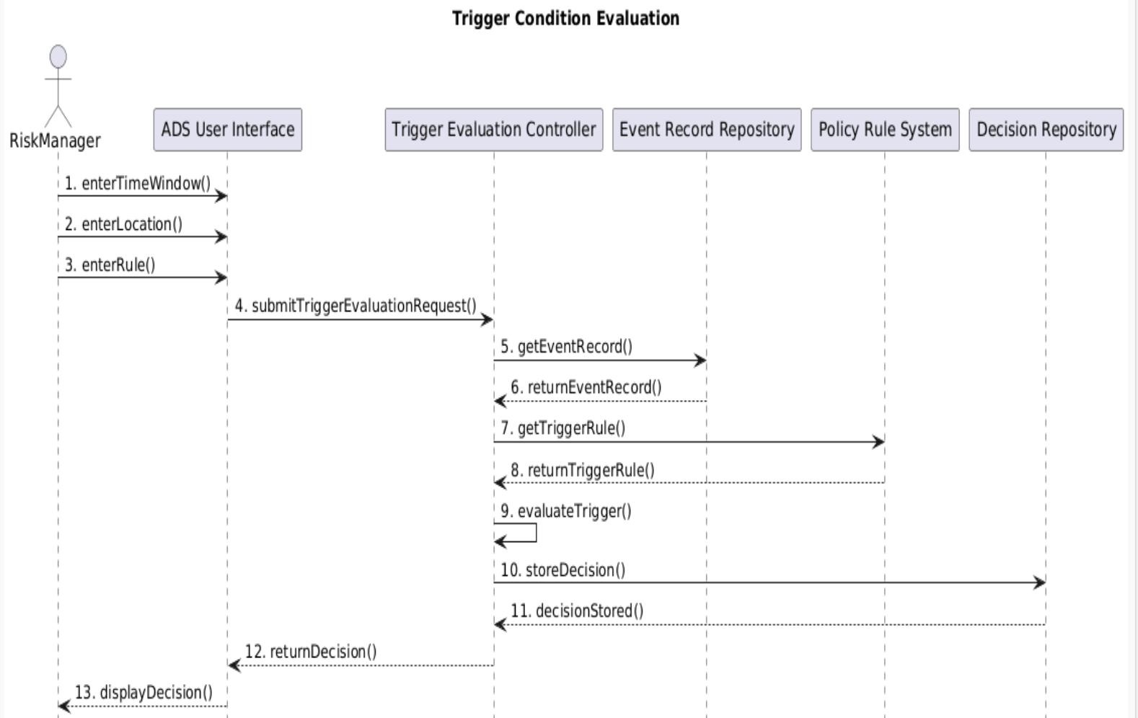

2.4 Confidence Score Generation
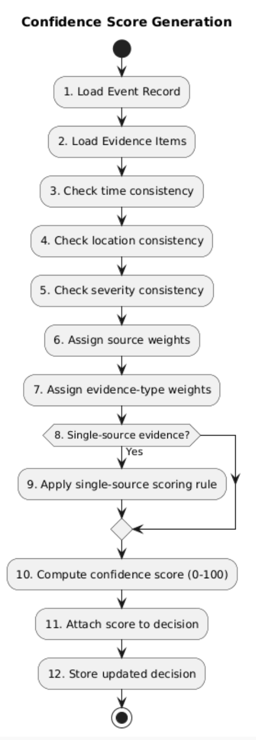

2.5 Evidence Report Generation
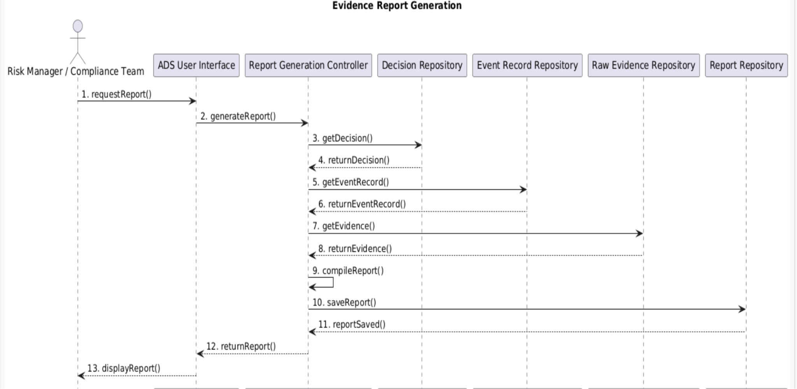

2.6 Search Verified Events
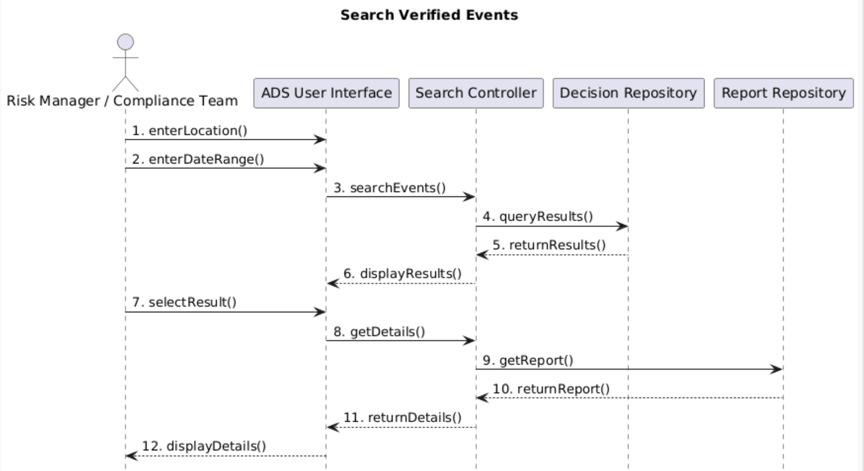

2.7 Map and Timeline View
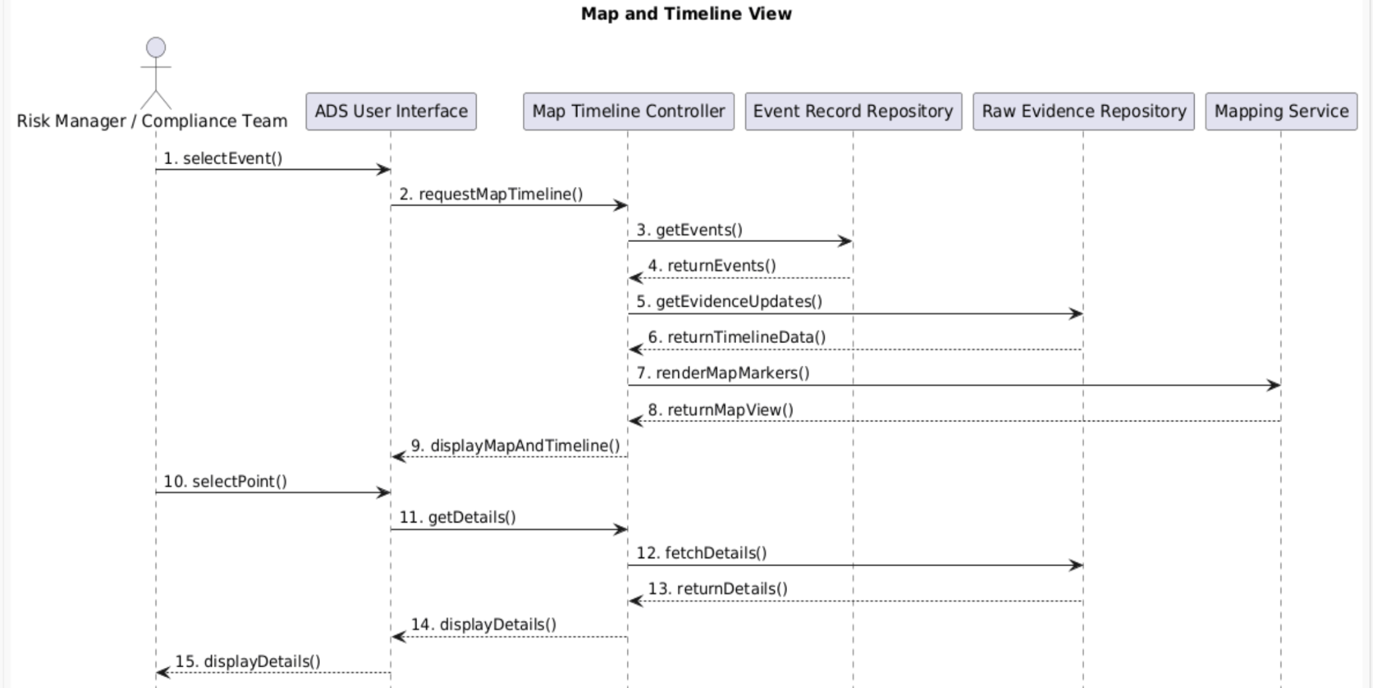

Structural Design
